**Assignment-2 on Spring Security**

1. Create Role based login application using Spring security where based on the Role redirect to difference URLs upon login to their assigned Role.

config

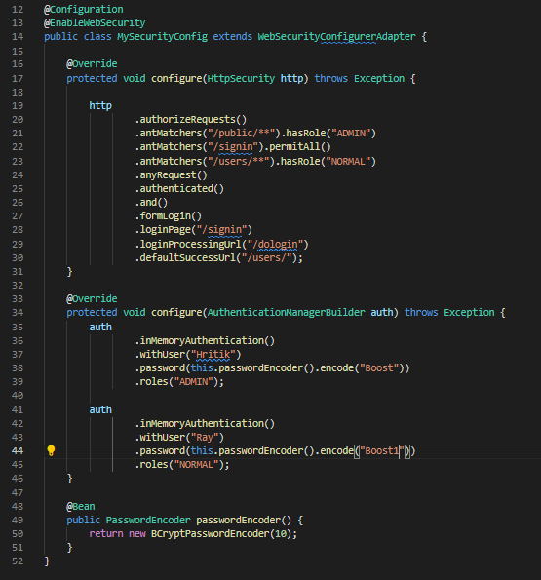

(“/home”)

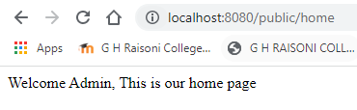

(“/login”)

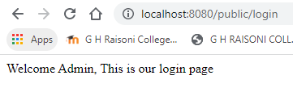

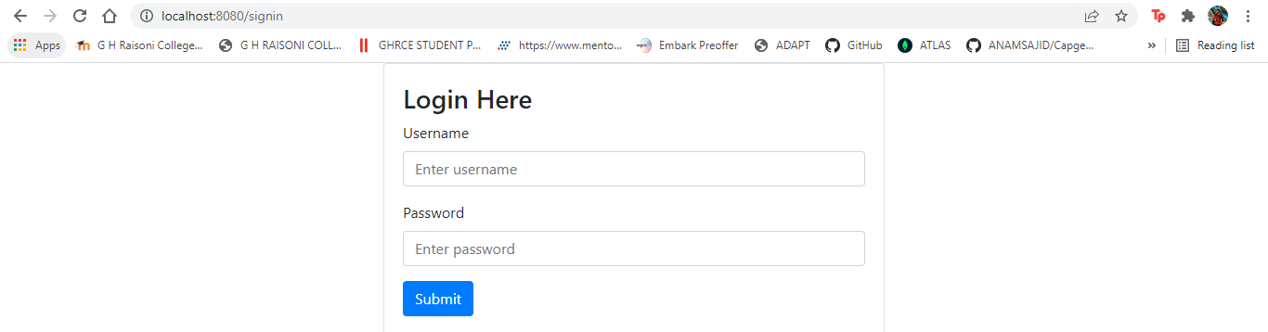

1. Any application, which takes Security seriously, should NEVER store passwords in plain text format. Passwords should always be encoded using a secure hashing algorithm. There are many standard algorithms like SHA or MD5 which combined with a proper SALT can be a good choice for password encoding. Create Sample login Spring Security application which provides BCryptPasswordEncoder, and implementation of Spring’s PasswordEncoder interface that uses the BCrypt strong hashing function to encode the password.

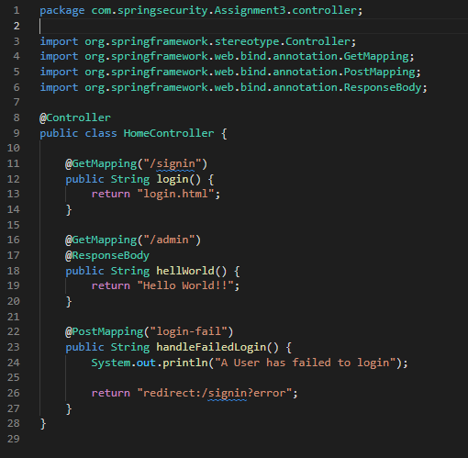

Encrypted password



1. These days Applications offers remember the identity of user between sessions. Basically, during login, when you ask for Remember-Me support, application will send a cookie to the browser during login. This cookie will be stored at browser side and will remain there for certain period(defined by cookie lifetime). Next time when you try to access the application, browser will detect the cookie (if still valid) and user will be automatically logged in, without providing userid/password e.g. create sample login Spring security application using Hash-Based Token Approach

config

